VISVESVARAYA TECHNOLOGICAL UNIVERSITY
“JnanaSangama”, Belgaum -590014, Karnataka.

LAB REPORT
on
Artificial Intelligence (23CS5PCAIN)
Submitted by
Aishwarya R (1BM23CS018)
in partial fulfillment for the award of the degree of
BACHELOR OF ENGINEERING
in
COMPUTER SCIENCE AND ENGINEERING

B.M.S. COLLEGE OF ENGINEERING
(Autonomous Institution under VTU)
BENGALURU-560019
Aug 2025 to Dec 2025

B.M.S. College of Engineering,
Bull Temple Road, Bangalore 560019
(Affiliated To Visvesvaraya Technological University, Belgaum)
Department of Computer Science and Engineering

CERTIFICATE
This is to certify that the Lab work entitled “Artificial Intelligence (23CS5PCAIN)” carried out by Aishwarya R(1BM23CS018), who is bonafide student of B.M.S. College of Engineering. It is in partial fulfillment for the award of Bachelor of Engineering in Computer Science and Engineering of the Visvesvaraya Technological University, Belgaum. The Lab report has been approved as it satisfies the academic requirements in respect of an Artificial Intelligence (23CS5PCAIN) work prescribed for the said degree.

Swathi Sridharan  Assistant Professor  Department of CSE, BMSCE | Dr. Kavitha Sooda  Professor & HOD  Department of CSE, BMSCE

Index
Sl.  No. | Date | Experiment Title | Page No.
1 | 20-8-2025 | Implement Tic –Tac –Toe Game  Implement vacuum cleaner agent | 4-13
2 | 3-9-2025 | Implement 8 puzzle problems using Depth First Search (DFS)  Implement Iterative deepening search algorithm | 14-20
3 | 10-9-2025 | Implement A* search algorithm | 21-30
4 | 10-09-2025 | Implement Hill Climbing search algorithm to solve N-Queens problem | 31-32
5 | 10-09-2025 | Simulated Annealing to Solve 8-Queens problem | 33-34
6 | 15-10-2025 | Create a knowledge base using propositional logic and show that the given query entails the knowledge base or not. | 35-36
7 | 29-10-2025 | Implement unification in first order logic | 37-39
8 | 29-10-2025 | Create a knowledge base consisting of first order logic statements and prove the given query using forward reasoning. | 40-41
9 | 11-11-2025 | Create a knowledge base consisting of first order logic statements and prove the given query using Resolution | 42-
10 | 11-11-2025 | Implement Alpha-Beta Pruning.



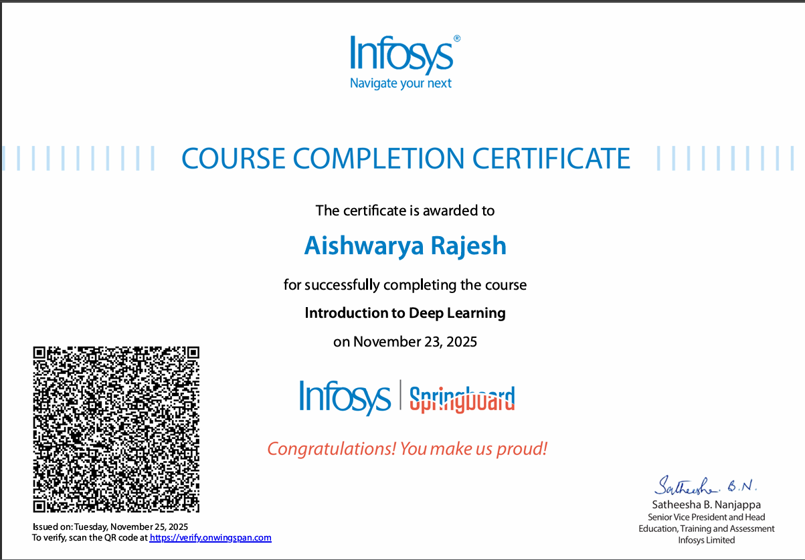

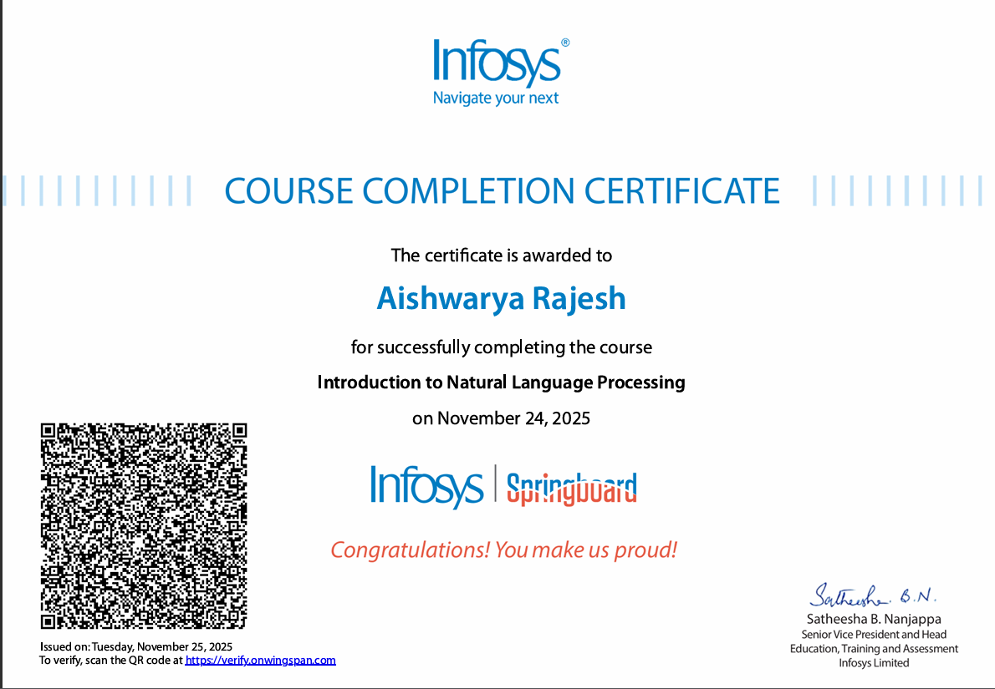

Github Link: https://github.com/Aishnir/AI-lab

\

Program 1
Implement Tic –Tac –Toe Game

Algorithm:
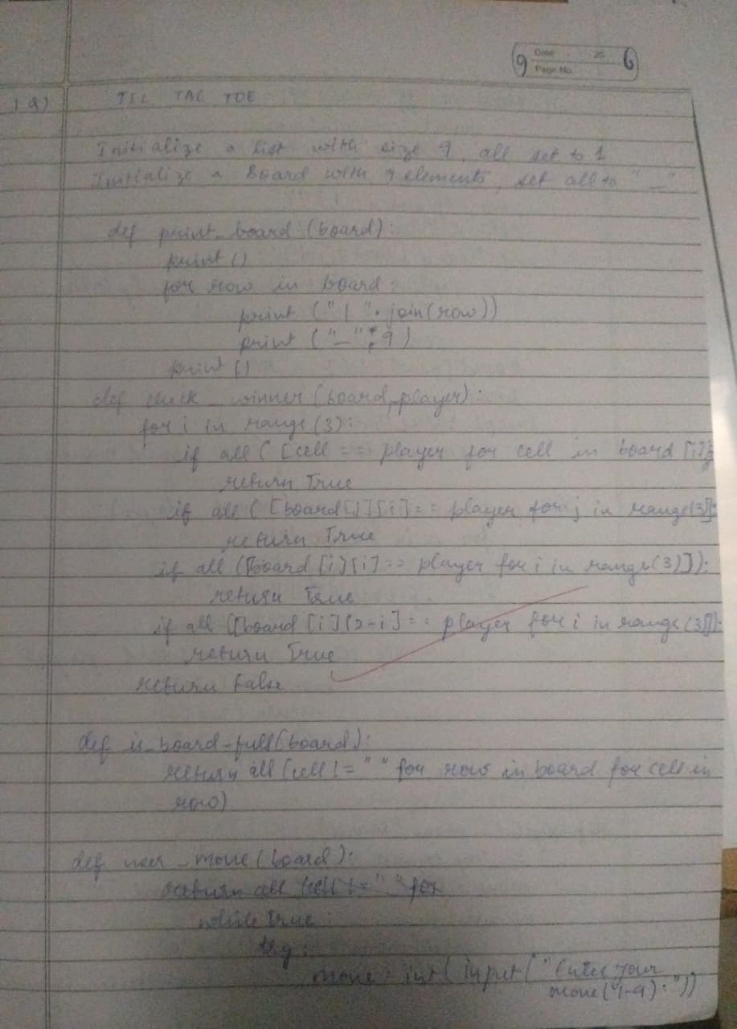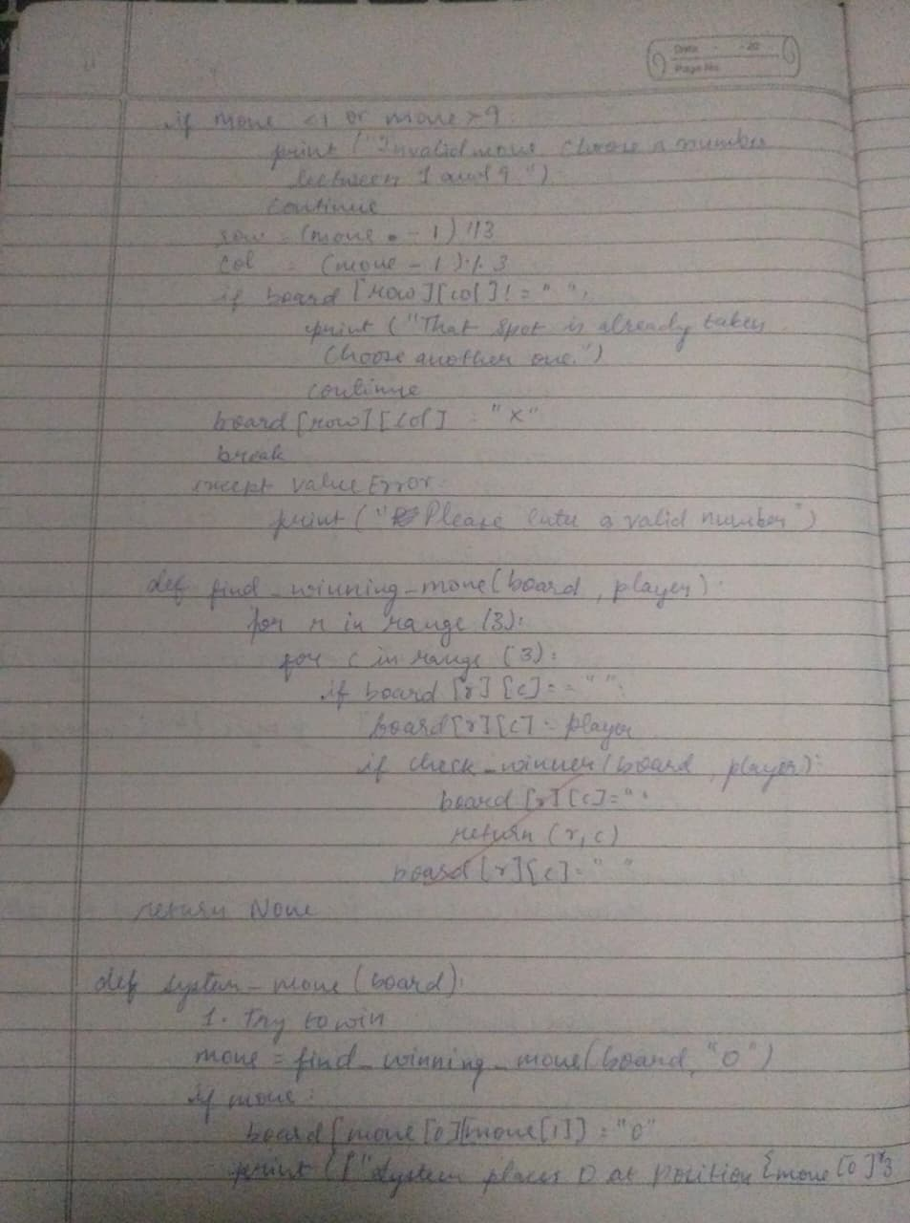

Code:
def print_board(board):
print("\nCurrent Board:")
for row in board:
print(row)
print()
def check_winner(board, player):
for i in range(3):
if all(cell == player for cell in board[i]):
return True
if all(board[j][i] == player for j in range(3)):
return True
if all(board[i][i] == player for i in range(3)):
return True
if all(board[i][2 - i] == player for i in range(3)):
return True
return False
def is_full(board):
return all(cell != " " for row in board for cell in row)
def tic_tac_toe():
board = [[" " for _ in range(3)] for _ in range(3)]
current_player = "X"
move_count = 0
print("Tic-Tac-Toe Game (3x3 Matrix Format)\n")
print_board(board)
while True:
try:
row = int(input(f"Player {current_player}, enter row (0-2): "))
col = int(input(f"Player {current_player}, enter col (0-2): "))
except ValueError:
print("Please enter integers between 0 and 2.")
continue
if not (0 <= row <= 2 and 0 <= col <= 2):
print("Invalid position. Try again.")
continue
if board[row][col] != " ":
print("Cell already filled. Choose another.")
continue
board[row][col] = current_player
move_count += 1
print_board(board)
if check_winner(board, current_player):
print(f"Player {current_player} wins!")
break
if is_full(board):
print("Game is a draw.")
break
current_player = "O" if current_player == "X" else "X"
print(f"Total moves (cost): {move_count}")
tic_tac_toe()

Output case1:
Tic-Tac-Toe Game (3x3 Matrix Format)

Current Board:
[' ', ' ', ' ']
[' ', ' ', ' ']
[' ', ' ', ' ']

Player X, enter row (0-2): 1
Player X, enter col (0-2): 1

Current Board:
[' ', ' ', ' ']
[' ', 'X', ' ']
[' ', ' ', ' ']

Player O, enter row (0-2): 0
Player O, enter col (0-2): 2

Current Board:
[' ', ' ', 'O']
[' ', 'X', ' ']
[' ', ' ', ' ']

Player X, enter row (0-2): 1
Player X, enter col (0-2): 0

Current Board:
[' ', ' ', 'O']
['X', 'X', ' ']
[' ', ' ', ' ']

Player O, enter row (0-2): 2
Player O, enter col (0-2): 1

Current Board:
[' ', ' ', 'O']
['X', 'X', ' ']
[' ', 'O', ' ']

Player X, enter row (0-2): 2
Player X, enter col (0-2): 2

Current Board:
[' ', ' ', 'O']
['X', 'X', ' ']
[' ', 'O', 'X']

Player O, enter row (0-2): 2
Player O, enter col (0-2): 0

Current Board:
[' ', ' ', 'O']
['X', 'X', ' ']
['O', 'O', 'X']

Player X, enter row (0-2): 0
Player X, enter col (0-2): 1

Current Board:
[' ', 'X', 'O']
['X', 'X', ' ']
['O', 'O', 'X']

Player O, enter row (0-2): 1
Player O, enter col (0-2): 2

Current Board:
[' ', 'X', 'O']
['X', 'X', 'O']
['O', 'O', 'X']

Player X, enter row (0-2): 0
Player X, enter col (0-2): 0

Current Board:
['X', 'X', 'O']
['X', 'X', 'O']
['O', 'O', 'X']

Player X wins!
Total moves (cost): 9

Output case2:
Tic-Tac-Toe Game (3x3 Matrix Format)

Current Board:
[' ', ' ', ' ']
[' ', ' ', ' ']
[' ', ' ', ' ']

Player X, enter row (0-2): 0
Player X, enter col (0-2): 2

Current Board:
[' ', ' ', 'X']
[' ', ' ', ' ']
[' ', ' ', ' ']

Player O, enter row (0-2): 2
Player O, enter col (0-2): 1

Current Board:
[' ', ' ', 'X']
[' ', ' ', ' ']
[' ', 'O', ' ']

Player X, enter row (0-2): 0
Player X, enter col (0-2): 0

Current Board:
['X', ' ', 'X']
[' ', ' ', ' ']
[' ', 'O', ' ']

Player O, enter row (0-2): 0
Player O, enter col (0-2): 1

Current Board:
['X', 'O', 'X']
[' ', ' ', ' ']
[' ', 'O', ' ']

Player X, enter row (0-2): 2
Player X, enter col (0-2): 0

Current Board:
['X', 'O', 'X']
[' ', ' ', ' ']
['X', 'O', ' ']

Player O, enter row (0-2): 1
Player O, enter col (0-2): 1

Current Board:
['X', 'O', 'X']
[' ', 'O', ' ']
['X', 'O', ' ']

Player O wins!
Total moves (cost): 6

Output case3:
Tic-Tac-Toe Game (3x3 Matrix Format):
Current Board:
[' ', ' ', ' ']
[' ', ' ', ' ']
[' ', ' ', ' ']

Player X, enter row (0-2): 1
Player X, enter col (0-2): 0
Current Board:
[' ', ' ', ' ']
['X', ' ', ' ']
[' ', ' ', ' ']

Player O, enter row (0-2): 0
Player O, enter col (0-2): 2

Current Board:
[' ', ' ', 'O']
['X', ' ', ' ']
[' ', ' ', ' ']

Player X, enter row (0-2): 2
Player X, enter col (0-2): 0

Current Board:
[' ', ' ', 'O']
['X', ' ', ' ']
['X', ' ', ' ']

Player O, enter row (0-2): 0
Player O, enter col (0-2): 0

Current Board:
['O', ' ', 'O']
['X', ' ', ' ']
['X', ' ', ' ']

Player X, enter row (0-2): 0
Player X, enter col (0-2): 1

Current Board:
['O', 'X', 'O']
['X', ' ', ' ']
['X', ' ', ' ']

Player O, enter row (0-2): 2
Player O, enter col (0-2): 1

Current Board:
['O', 'X', 'O']
['X', ' ', ' ']
['X', 'O', ' ']

Player X, enter row (0-2): 2
Player X, enter col (0-2): 2

Current Board:
['O', 'X', 'O']
['X', ' ', ' ']
['X', 'O', 'X']

Player O, enter row (0-2): 1
Player O, enter col (0-2): 1

Current Board:
['O', 'X', 'O']
['X', 'O', ' ']
['X', 'O', 'X']

Player X, enter row (0-2): 1
Player X, enter col (0-2): 2

Current Board:
['O', 'X', 'O']
['X', 'O', 'X']
['X', 'O', 'X']

Game is a draw.
Total moves (cost): 9

Implement vacuum cleaner agent

Algorithm:

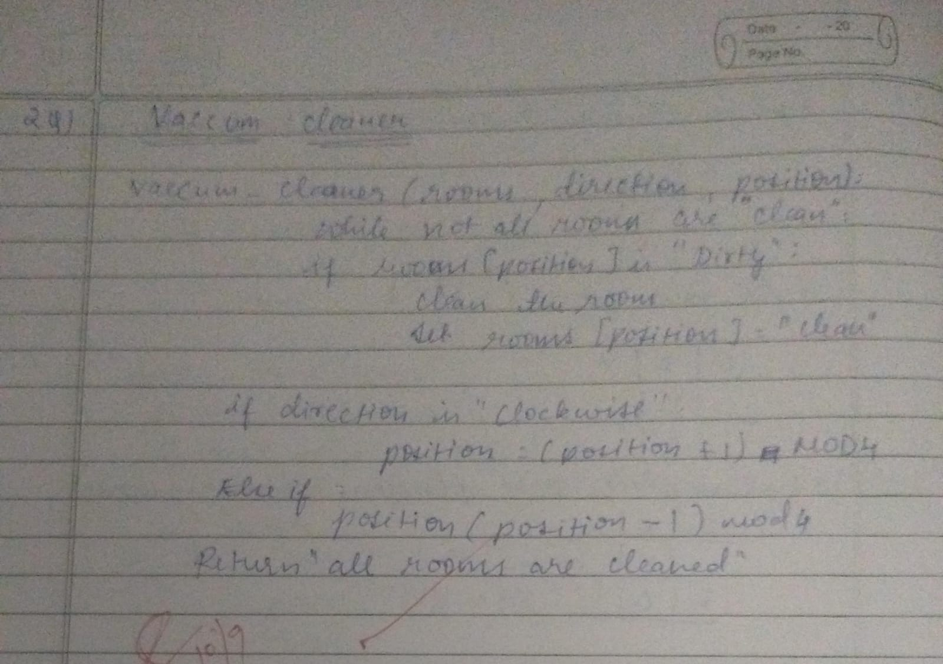

Code:
def vacuum_cleaner()
A = int(input("Enter state of A (0 for clean, 1 for dirty): "))
B = int(input("Enter state of B (0 for clean, 1 for dirty): "))
location = input("Enter location (A or B): ").upper()

cost = 0
state = {'A': A, 'B': B}

if location == 'A':
if state['A'] == 1: # If A is dirty
print("Cleaned A.")
state['A'] = 0
cost += 1
else:
print("A is clean")

if state['B'] == 1: # If B is dirty
print("Moving vacuum right")
print("Cleaned B.")
state['B'] = 0
cost += 1
print("Is B clean now? (0 if clean, 1 if dirty):", state['B'])
print("Is A dirty? (0 if clean, 1 if dirty):", state['A'])
print("B is clean")
print("Moving vacuum left")
else:
print("Turning vacuum off")

elif location == 'B':
if state['B'] == 1: # If B is dirty
print("Cleaned B.")
state['B'] = 0
cost += 1
else:
print("B is clean")

if state['A'] == 1: # If A is dirty
print("Moving vacuum left")
print("Cleaned A.")
state['A'] = 0
cost += 1
print("Is A clean now? (0 if clean, 1 if dirty):", state['A'])
print("Is B dirty? (0 if clean, 1 if dirty):", state['B'])
print("A is clean")
print("Moving vacuum right")
else:
print("Turning vacuum off")

print("Cost:", cost)
print(state)

vacuum_cleaner()

OUTPUT Case1:
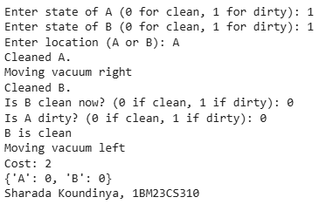
OUTPUT Case2:
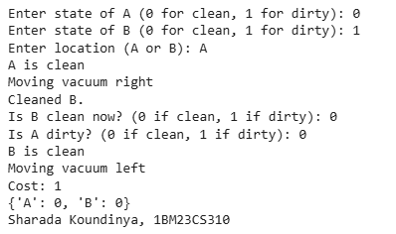

OUTPUT Case3:
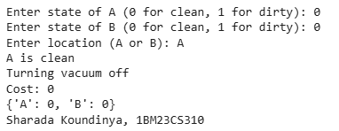

Program2

Implement 8 puzzle problems using Depth First Search (DFS)

Code:

def get_moves(state):
idx = state.index("_")
x, y = divmod(idx, 3)
moves = []
for dx, dy in [(-1,0),(1,0),(0,-1),(0,1)]:
nx, ny = x+dx, y+dy
if 0 <= nx < 3 and 0 <= ny < 3:
nidx = nx*3 + ny
lst = list(state)
lst[idx], lst[nidx] = lst[nidx], lst[idx]
moves.append("".join(lst))
return moves

def dfs(start, goal):
stack = [(start, 0)]
parent = {start: None}
visited = {start}
order = []

while stack:
state, cost = stack.pop()
order.append(state)
if state == goal:
path = []
while state:
path.append(state)
state = parent[state]
path.reverse()
return path, cost, order, visited
for move in reversed(get_moves(state)):
if move not in visited:
visited.add(move)
parent[move] = state
stack.append((move, cost+1))
return None, -1, order, visited

start = input("Enter initial state (e.g., 54_618732): ")
goal = input("Enter goal state (e.g., 12345678_): ")
path, cost, visited_order, visited_set = dfs(start, goal)

print("Visited nodes (till goal found):")
for v in visited_order:
for i in range(0, 9, 3):
print(v[i:i+3])
print()
if v == goal:
break

print("Steps (solution path):")
for p in path:
for i in range(0, 9, 3):
print(p[i:i+3])
print()

print("Cost (depth to goal):", cost)
print("Number of nodes visited:", len(visited_set))

Output:

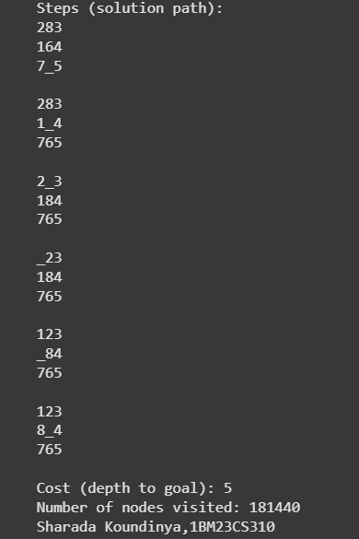

Implement Iterative deepening search algorithm

Algorithm:
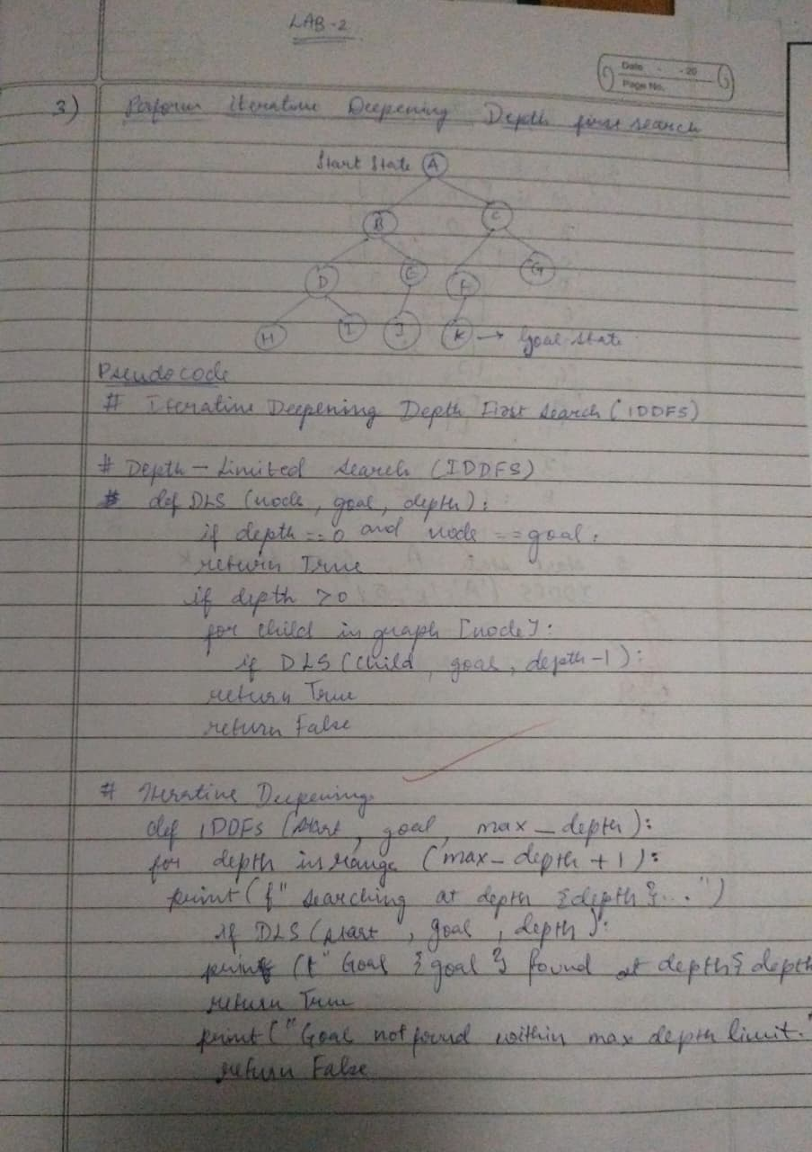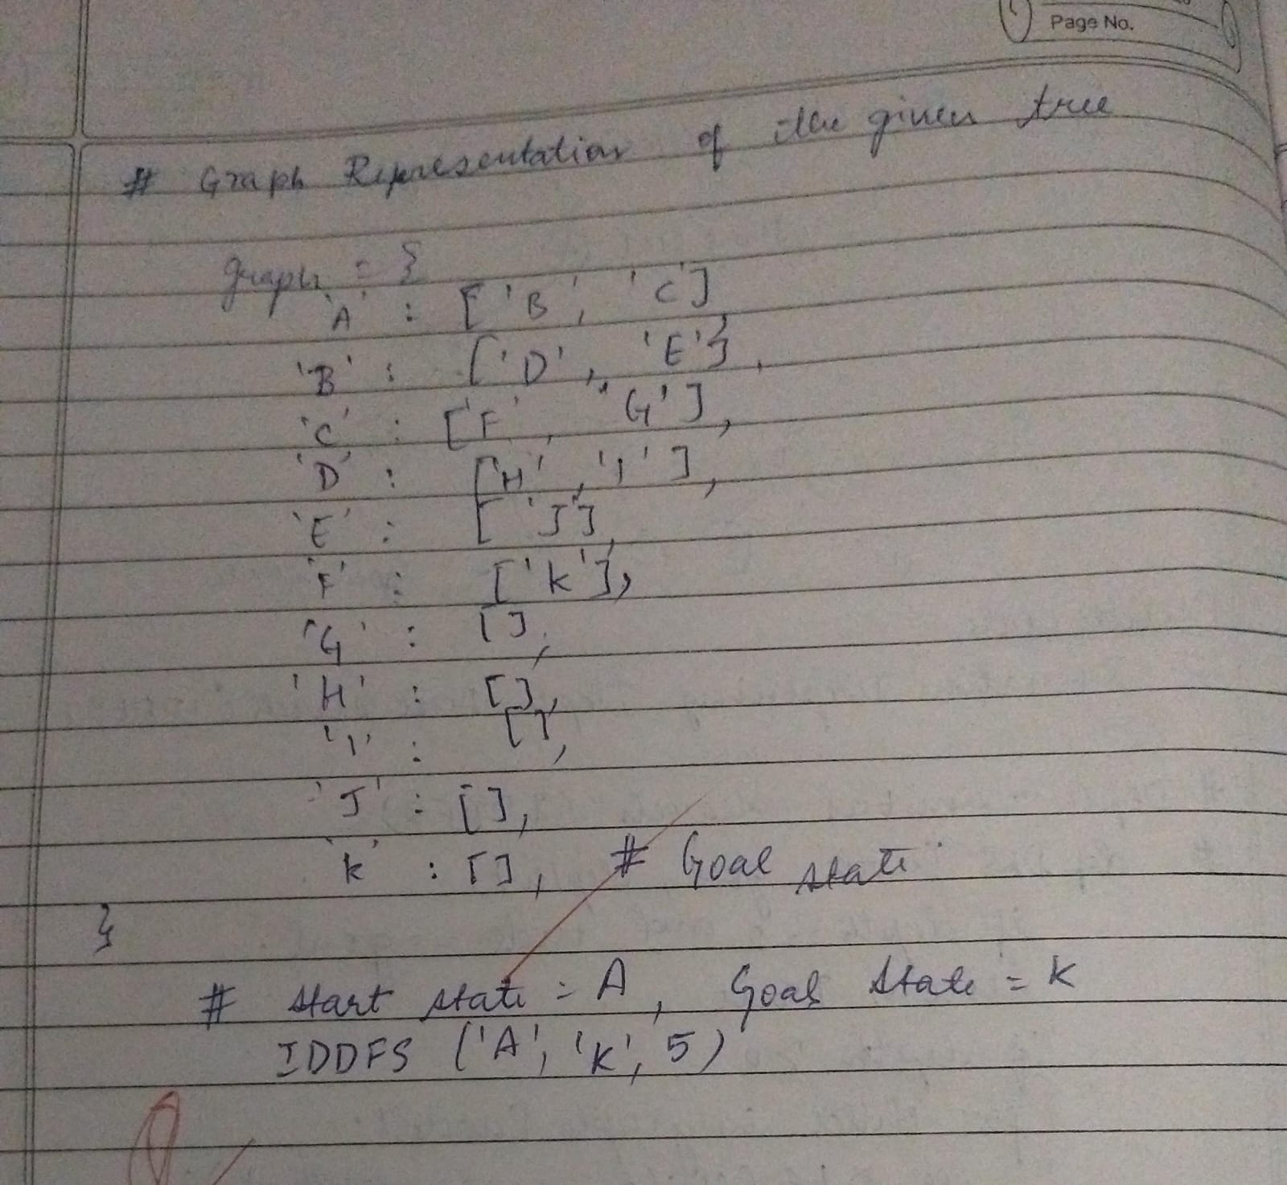

Code:

def get_neighbors(state):
neighbors = []
idx = state.index("0")
moves = [(-1, 0), (1, 0), (0, -1), (0, 1)]
x, y = divmod(idx, 3)

for dx, dy in moves:
nx, ny = x + dx, y + dy
if 0 <= nx < 3 and 0 <= ny < 3:
new_idx = nx * 3 + ny
state_list = list(state)
state_list[idx], state_list[new_idx] = state_list[new_idx], state_list[idx]
neighbors.append("".join(state_list))
return neighbors

def dfs_limit(start_state, goal_state, limit):
stack = [(start_state, 0)]
visited = set()
parent = {start_state: None}
path = []

while stack:
current_state, depth = stack.pop()

if current_state == goal_state:
while current_state:
path.append(current_state)
current_state = parent[current_state]
return path[::-1]

if depth < limit and current_state not in visited:
visited.add(current_state)
neighbors = get_neighbors(current_state)
neighbors.reverse() # Maintain consistent exploration order
for neighbor in neighbors:
if neighbor not in visited:
parent[neighbor] = current_state
stack.append((neighbor, depth + 1))
return None

def iddfs(start_state, goal_state, max_depth):
for limit in range(max_depth + 1):
print(f"Searching with depth limit: {limit}")
solution = dfs_limit(start_state, goal_state, limit)
if solution:
return solution
return None

print("Enter the initial state (enter 3 digits per row, separated by spaces, 0 for empty):")
initial_state_rows = []
for i in range(3):
row = input(f"Row {i+1}: ").split()
initial_state_rows.extend(row)
initial_state = "".join(initial_state_rows)

print("\nEnter the goal state (enter 3 digits per row, separated by spaces, 0 for empty):")
goal_state_rows = []
for i in range(3):
row = input(f"Row {i+1}: ").split()
goal_state_rows.extend(row)
goal_state = "".join(goal_state_rows)

max_depth = 50

solution = iddfs(initial_state, goal_state, max_depth)

if solution:
print("\nIDDFS solution path:")
for s in solution:
print(s[:3])
print(s[3:6])
print(s[6:])
print()
else:
print(f"\nNo solution found within the maximum depth of {max_depth}.")

Output:
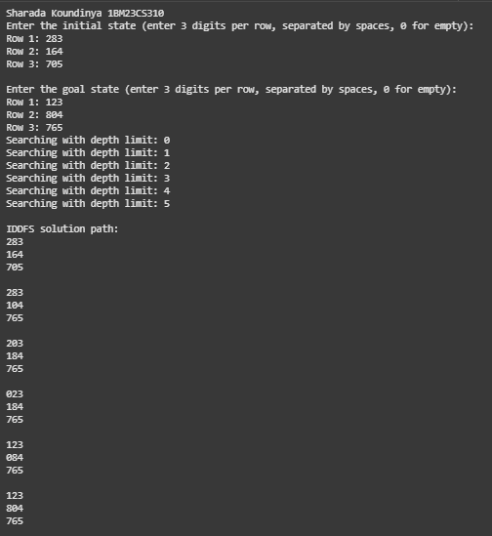

Program3
Implement A* search algorithm

Algorithm:
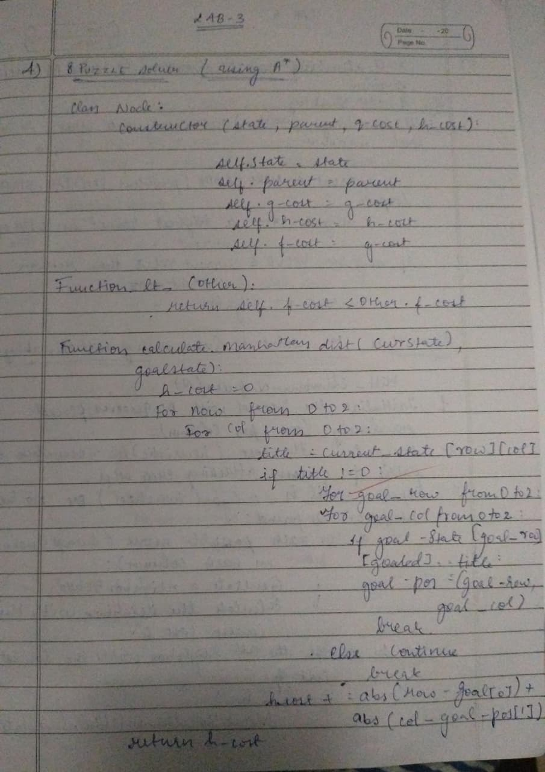

Code:
#MISPLACED TILE
import heapq
from itertools import count

def misplaced_heuristic(board, goal):
"""h(n): number of tiles not in their goal position (excluding blank 0)."""
n = len(board)
misplaced = 0
for i in range(n):
for j in range(n):
if board[i][j] != 0 and board[i][j] != goal[i][j]:
misplaced += 1
return misplaced

def find_blank(board):
n = len(board)
for i in range(n):
for j in range(n):
if board[i][j] == 0:
return i, j
raise ValueError("Board does not contain a blank tile (0)")

def neighbors(board):
"""Generate neighboring boards by sliding one tile into the blank."""
n = len(board)
x, y = find_blank(board)
dirs = [(0,1),(0,-1),(1,0),(-1,0)]
res = []
for dx, dy in dirs:
nx, ny = x + dx, y + dy
if 0 <= nx < n and 0 <= ny < n:
b = [list(row) for row in board]
b[x][y], b[nx][ny] = b[nx][ny], b[x][y]
res.append(tuple(tuple(row) for row in b))
return res

def flatten(board):
return [x for row in board for x in row]

def inversion_count(seq):
arr = [x for x in seq if x != 0]
inv = 0
for i in range(len(arr)):
for j in range(i+1, len(arr)):
if arr[i] > arr[j]:
inv += 1
return inv

def blank_row_from_bottom(board):
n = len(board)
for i in range(n):
for j in range(n):
if board[i][j] == 0:
return n - i
raise ValueError("Board does not contain a blank tile (0)")

def is_solvable(start, goal):
"""General n-puzzle solvability test (odd/even width)."""
n = len(start)
start_flat = flatten(start)
goal_flat = flatten(goal)

pos = {val: idx for idx, val in enumerate(goal_flat)}
start_perm = [pos[val] for val in start_flat]

inv = inversion_count(start_perm)

if n % 2 == 1:
# odd grid: inversions parity must be even
return inv % 2 == 0
else:
# even grid: blank row from bottom parity matters
blank_row = blank_row_from_bottom(start)
goal_blank_row = blank_row_from_bottom(goal)
# When using relative permutation to goal, parity of blank rows must match
return (inv + blank_row) % 2 == (0 + goal_blank_row) % 2

def reconstruct_path(came_from, current):
path = [current]
while current in came_from:
current = came_from[current]
path.append(current)
path.reverse()
return path

def a_star_misplaced(start, goal):
start = tuple(tuple(row) for row in start)
goal = tuple(tuple(row) for row in goal)

if len(start) != len(start[0]) or len(goal) != len(goal[0]) or len(start) != len(goal):
raise ValueError("Initial and goal must be square boards of the same size.")

start_vals = sorted(flatten(start))
goal_vals = sorted(flatten(goal))
if start_vals != goal_vals:
raise ValueError("Initial and goal must contain the same set of tiles.")

if not is_solvable(start, goal):
return None, None, 0, 0 # unsolvable

counter = count() # tie-breaker

h0 = misplaced_heuristic(start, goal)
g_score = {start: 0}
f0 = h0

open_heap = [(f0, next(counter), start)]
open_set = {start: f0}
closed = set()
came_from = {}

expansions = 0

while open_heap:
_, _, current = heapq.heappop(open_heap)
if current in closed:
continue
closed.add(current)

if current == goal:
path = reconstruct_path(came_from, current)
return path, g_score[current], expansions, len(closed)

expansions += 1

for nb in neighbors(current):
tentative_g = g_score[current] + 1
if nb in closed:
continue
if nb not in g_score or tentative_g < g_score[nb]:
came_from[nb] = current
g_score[nb] = tentative_g
h = misplaced_heuristic(nb, goal)
f = tentative_g + h
if nb not in open_set or f < open_set[nb]:
heapq.heappush(open_heap, (f, next(counter), nb))
open_set[nb] = f

return None, None, expansions, len(closed)

def read_board(n, prompt):
print(prompt)
board = []
for i in range(n):
row = list(map(int, input().split()))
if len(row) != n:
raise ValueError(f"Row {i+1} must contain exactly {n} integers.")
board.append(row)
return board

def print_board(board):
for row in board:
print(" ".join(f"{x}" for x in row))

def main():
try:
n = int(input("Enter puzzle size n (e.g., 3 for 3x3): ").strip())
initial = read_board(n, "Enter initial state row by row (use 0 for blank):")
goal = read_board(n, "Enter goal state row by row (use 0 for blank):")

result = a_star_misplaced(initial, goal)
path, cost, expansions, explored = result

if path is None:
print("No solution (unsolvable with given start/goal).")
return

print("\nSolution path (each state shows g, h, f):\n")
for idx, state in enumerate(path):
g = idx # each step costs 1
h = misplaced_heuristic(state, tuple(tuple(r) for r in goal))
f = g + h
print(f"Step {idx}: g={g}, h={h}, f={f}")
print_board(state)
print()

print(f"Total cost (number of moves): {cost}")
print(f"Nodes expanded: {expansions}")
print(f"Nodes explored (unique): {explored}")

except Exception as e:
print("Error:", e)

if __name__ == "__main__":
main()

Output:
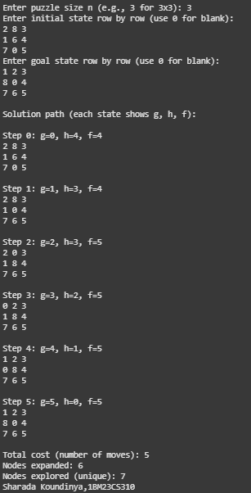

Code:
#MANHATTAN DISTANCE
import heapq
from itertools import count

def misplaced_heuristic(board, goal):
misplaced = 0
n = len(board)
for i in range(n):
for j in range(n):
if board[i][j] != 0 and board[i][j] != goal[i][j]:
misplaced += 1
return misplaced

def manhattan_heuristic(board, goal):
n = len(board)
# Map goal positions for each tile
goal_pos = {}
for i in range(n):
for j in range(n):
goal_pos[goal[i][j]] = (i, j)

dist = 0
for i in range(n):
for j in range(n):
val = board[i][j]
if val != 0:
gi, gj = goal_pos[val]
dist += abs(i - gi) + abs(j - gj)
return dist

def find_blank(board):
n = len(board)
for i in range(n):
for j in range(n):
if board[i][j] == 0:
return i, j
raise ValueError("Board does not contain a blank tile (0)")

def neighbors(board):
n = len(board)
x, y = find_blank(board)
dirs = [(0,1),(0,-1),(1,0),(-1,0)]
res = []
for dx, dy in dirs:
nx, ny = x + dx, y + dy
if 0 <= nx < n and 0 <= ny < n:
b = [list(row) for row in board]
b[x][y], b[nx][ny] = b[nx][ny], b[x][y]
res.append(tuple(tuple(row) for row in b))
return res

def flatten(board):
return [x for row in board for x in row]

def inversion_count(seq):
arr = [x for x in seq if x != 0]
inv = 0
for i in range(len(arr)):
for j in range(i+1, len(arr)):
if arr[i] > arr[j]:
inv += 1
return inv

def blank_row_from_bottom(board):
n = len(board)
for i in range(n):
for j in range(n):
if board[i][j] == 0:
return n - i
raise ValueError("Board does not contain a blank tile (0)")

def is_solvable(start, goal):
n = len(start)
start_flat = flatten(start)
goal_flat = flatten(goal)

pos = {val: idx for idx, val in enumerate(goal_flat)}
start_perm = [pos[val] for val in start_flat]

inv = inversion_count(start_perm)

if n % 2 == 1:
return inv % 2 == 0
else:
blank_row = blank_row_from_bottom(start)
goal_blank_row = blank_row_from_bottom(goal)
return (inv + blank_row) % 2 == (0 + goal_blank_row) % 2

def reconstruct_path(came_from, current):
path = [current]
while current in came_from:
current = came_from[current]
path.append(current)
path.reverse()
return path

def a_star_manhattan(start, goal):
start = tuple(tuple(row) for row in start)
goal = tuple(tuple(row) for row in goal)

if len(start) != len(start[0]) or len(goal) != len(goal[0]) or len(start) != len(goal):
raise ValueError("Initial and goal must be square boards of the same size.")

start_vals = sorted(flatten(start))
goal_vals = sorted(flatten(goal))
if start_vals != goal_vals:
raise ValueError("Initial and goal must contain the same set of tiles.")

if not is_solvable(start, goal):
return None, None, 0, 0

counter = count()
h0 = manhattan_heuristic(start, goal)
g_score = {start: 0}
f0 = h0

open_heap = [(f0, next(counter), start)]
open_set = {start: f0}
closed = set()
came_from = {}

expansions = 0

while open_heap:
_, _, current = heapq.heappop(open_heap)
if current in closed:
continue
closed.add(current)

if current == goal:
path = reconstruct_path(came_from, current)
return path, g_score[current], expansions, len(closed)

expansions += 1

for nb in neighbors(current):
tentative_g = g_score[current] + 1
if nb in closed:
continue
if nb not in g_score or tentative_g < g_score[nb]:
came_from[nb] = current
g_score[nb] = tentative_g
h = manhattan_heuristic(nb, goal)
f = tentative_g + h
if nb not in open_set or f < open_set[nb]:
heapq.heappush(open_heap, (f, next(counter), nb))
open_set[nb] = f

return None, None, expansions, len(closed)

def read_board(n, prompt):
print(prompt)
board = []
for i in range(n):
row = list(map(int, input().split()))
if len(row) != n:
raise ValueError(f"Row {i+1} must contain exactly {n} integers.")
board.append(row)
return board

def print_board(board):
for row in board:
print(" ".join(f"{x}" for x in row))

def main():
try:
n = int(input("Enter puzzle size n (e.g., 3 for 3x3): ").strip())
initial = read_board(n, "Enter initial state row by row (use 0 for blank):")
goal = read_board(n, "Enter goal state row by row (use 0 for blank):")

result = a_star_manhattan(initial, goal)
path, cost, expansions, explored = result

if path is None:
print("No solution (unsolvable with given start/goal).")
return

print("\nSolution path (each state shows g, h, f):\n")
for idx, state in enumerate(path):
g = idx
h = manhattan_heuristic(state, tuple(tuple(r) for r in goal))
f = g + h
print(f"Step {idx}: g={g}, h={h}, f={f}")
print_board(state)
print()

print(f"Total cost (number of moves): {cost}")
print(f"Nodes expanded: {expansions}")
print(f"Nodes explored (unique): {explored}")
print("Sharada Koundinya,1BM23CS310")

except Exception as e:
print("Error:", e)

if __name__ == "__main__":
main()

Output: 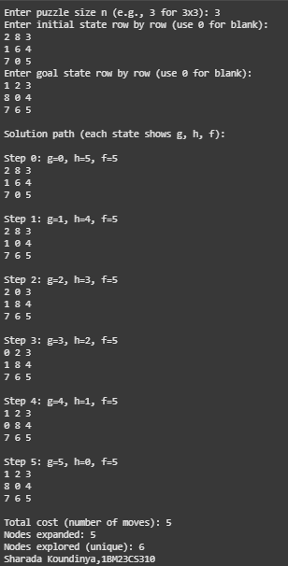

Program4

Implement Hill Climbing search algorithm to solve N-Queens problem

Algorithm:
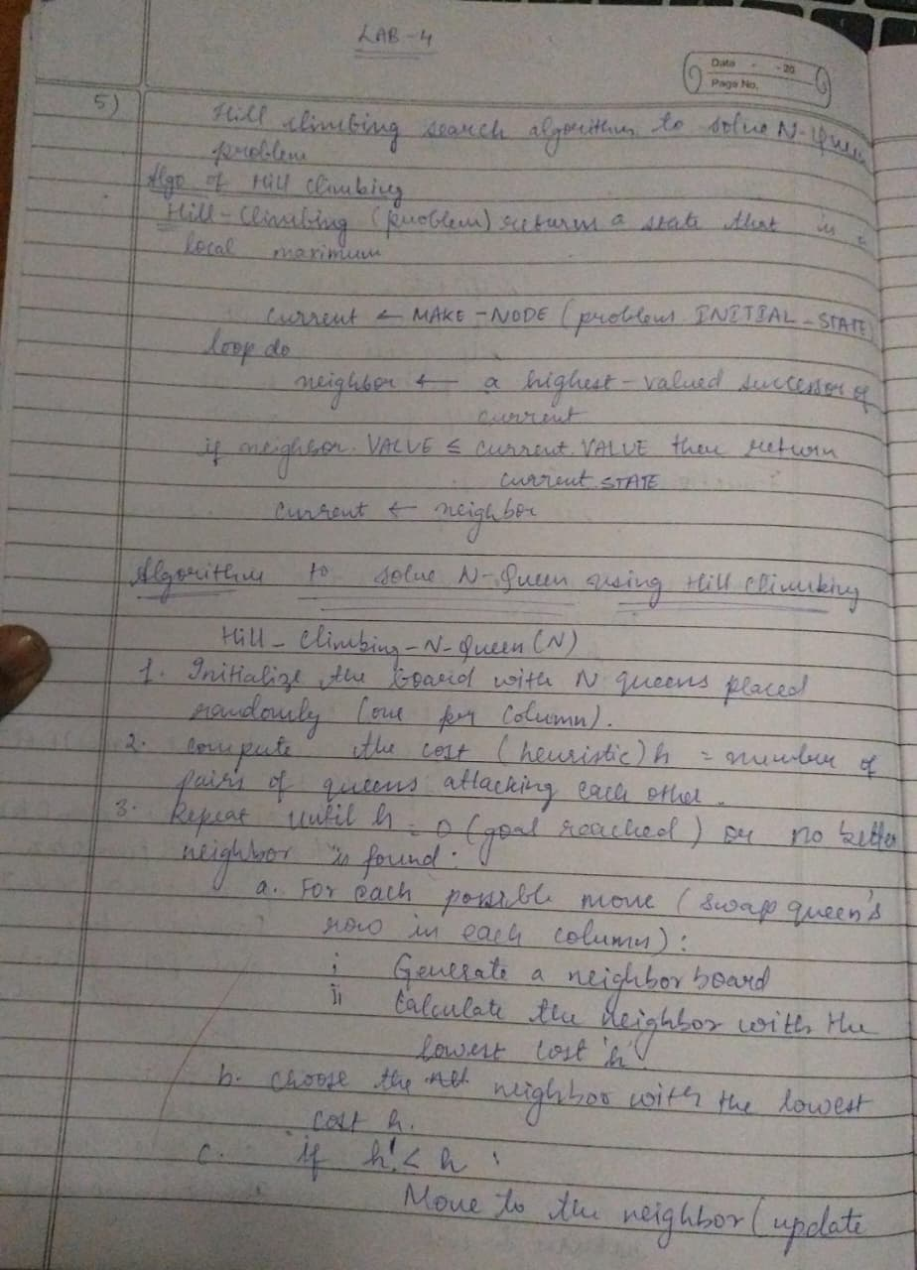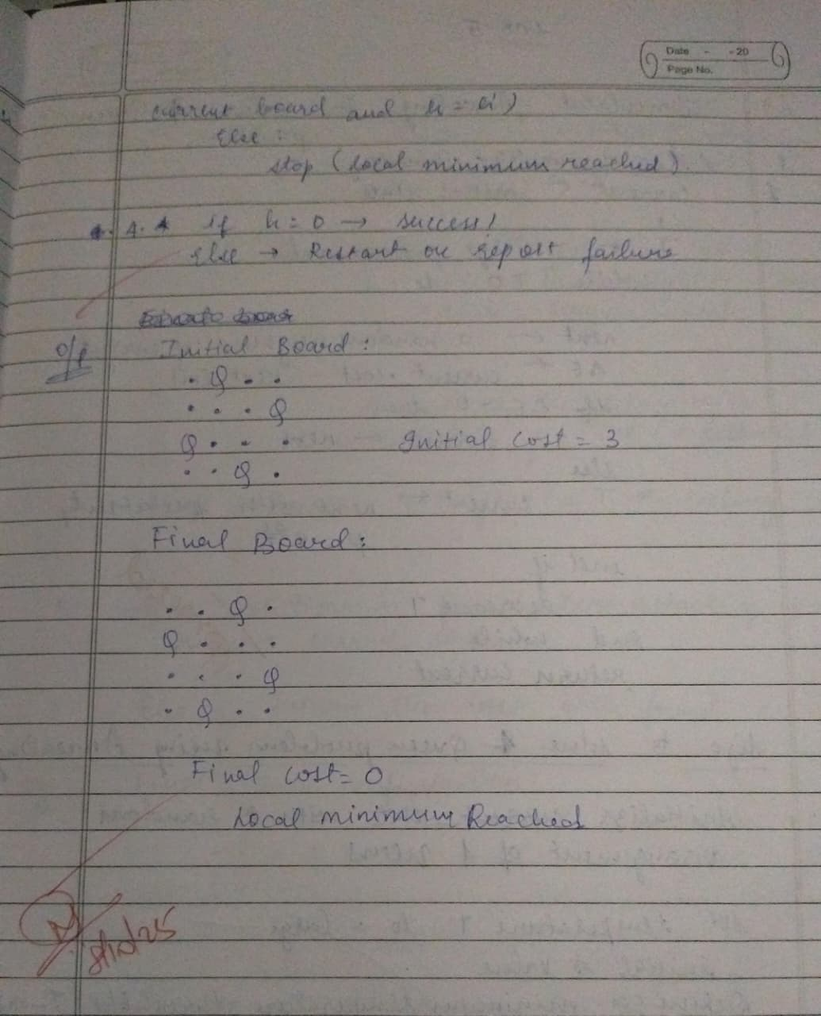

Code:
def calculate_cost(state):
cost = 0
n = len(state)
for i in range(n):
for j in range(i + 1, n):
if state[i] == state[j] or abs(state[i] - state[j]) == abs(i - j):
cost += 1
return cost

def generate_neighbors(state):
neighbors = []
n = len(state)
for col in range(n):
for row in range(n):
if state[col] != row: # move queen
new_state = list(state)
new_state[col] = row
neighbors.append(new_state)
return neighbors

def hill_climbing(initial_state):
current = initial_state
current_cost = calculate_cost(current)
step = 0

print(f"Step {step}: State = {current}, Cost = {current_cost}")

while True:
neighbors = generate_neighbors(current)
neighbor_costs = [(n, calculate_cost(n)) for n in neighbors]

# Print state space for this step
print("\nNeighbors and their costs:")
for n, c in neighbor_costs:
print(f" {n} -> Cost = {c}")

# Pick the best neighbor (lowest cost)
best_neighbor, best_cost = min(neighbor_costs, key=lambda x: x[1])

if best_cost >= current_cost:
break

step += 1
current, current_cost = best_neighbor, best_cost
print(f"\nStep {step}: Move to {current}, Cost = {current_cost}")

if current_cost == 0:
print("\nGoal reached! Solution found.")
break

initial_state = [3, 1, 2, 0]

hill_climbing(initial_state)

Output:
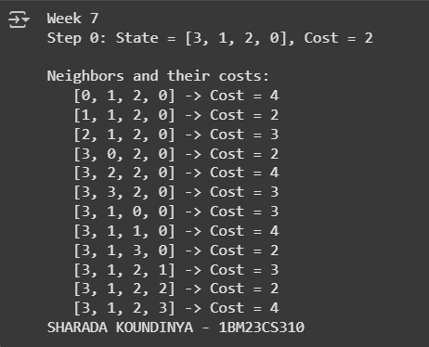

Program 5

Simulated Annealing to Solve 8-Queens problem

Algorithm:
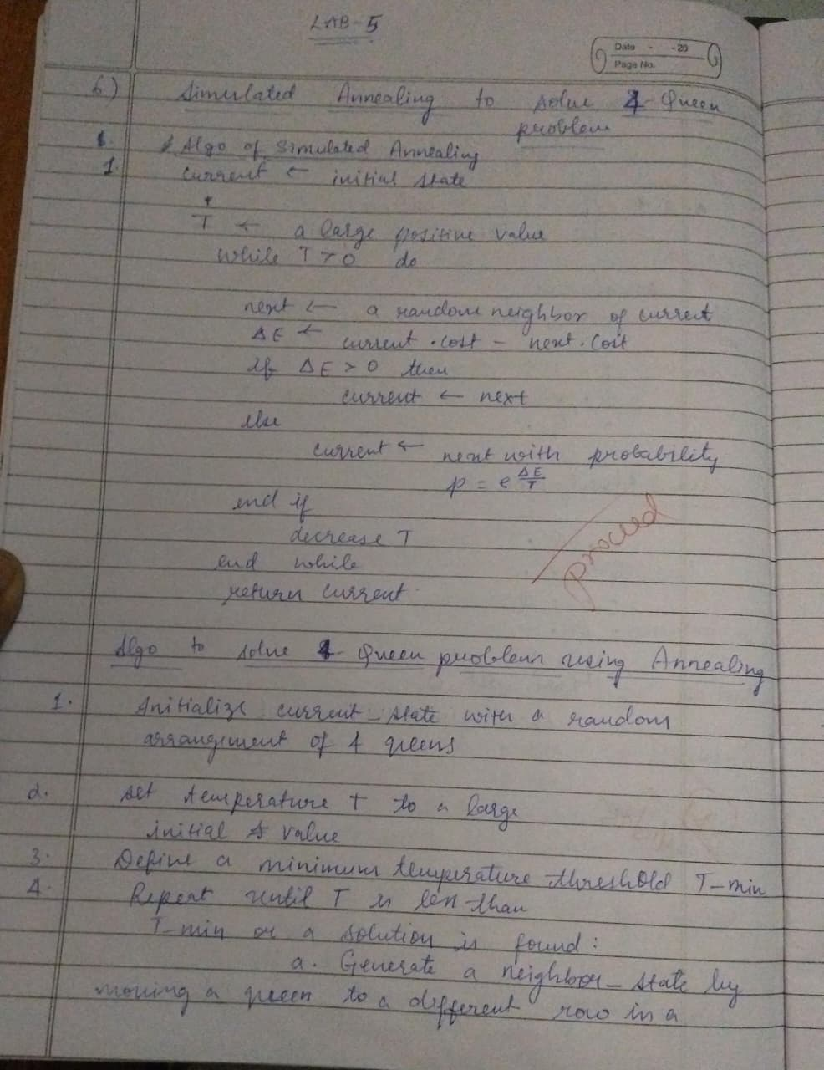
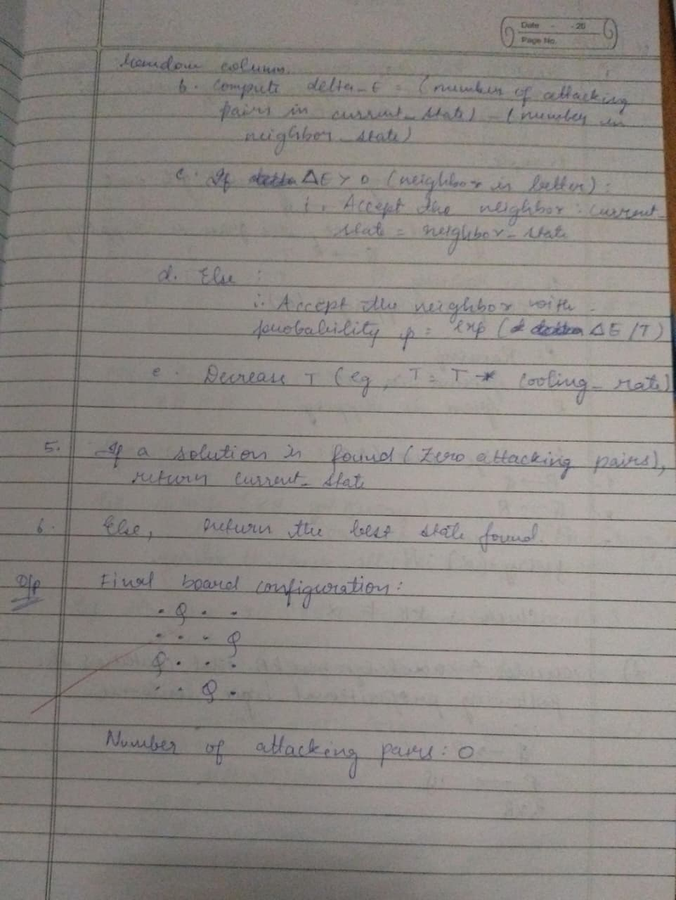
Code:
import random
import math

def calculate_cost(state):
cost = 0
n = len(state)
for i in range(n):
for j in range(i + 1, n):
if state[i] == state[j] or abs(state[i] - state[j]) == abs(i - j):
cost += 1
return cost

def get_random_neighbor(state):
n = len(state)
new_state = list(state)
col = random.randint(0, n - 1)
row = random.randint(0, n - 1)
new_state[col] = row
return new_state

def simulated_annealing(n=8, max_iterations=10000, initial_temp=100.0, cooling_rate=0.99):

current = [random.randint(0, n - 1) for _ in range(n)]
current_cost = calculate_cost(current)
best = current
best_cost = current_cost
temperature = initial_temp

for _ in range(max_iterations):
if current_cost == 0:
break

neighbor = get_random_neighbor(current)
neighbor_cost = calculate_cost(neighbor)
delta = neighbor_cost - current_cost

if delta < 0 or random.random() < math.exp(-delta / temperature):
current, current_cost = neighbor, neighbor_cost

if current_cost < best_cost:
best, best_cost = current, current_cost

temperature *= cooling_rate
if temperature < 1e-6:
break

return best, best_cost

best_state, best_cost = simulated_annealing()

print("The best position found:", best_state)
print("cost =", best_cost)

Output:
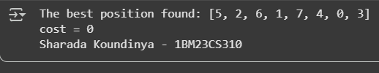

Program 6

Create a knowledge base using propositional logic and show that the given query entails the knowledge base or not.

Algorithm:
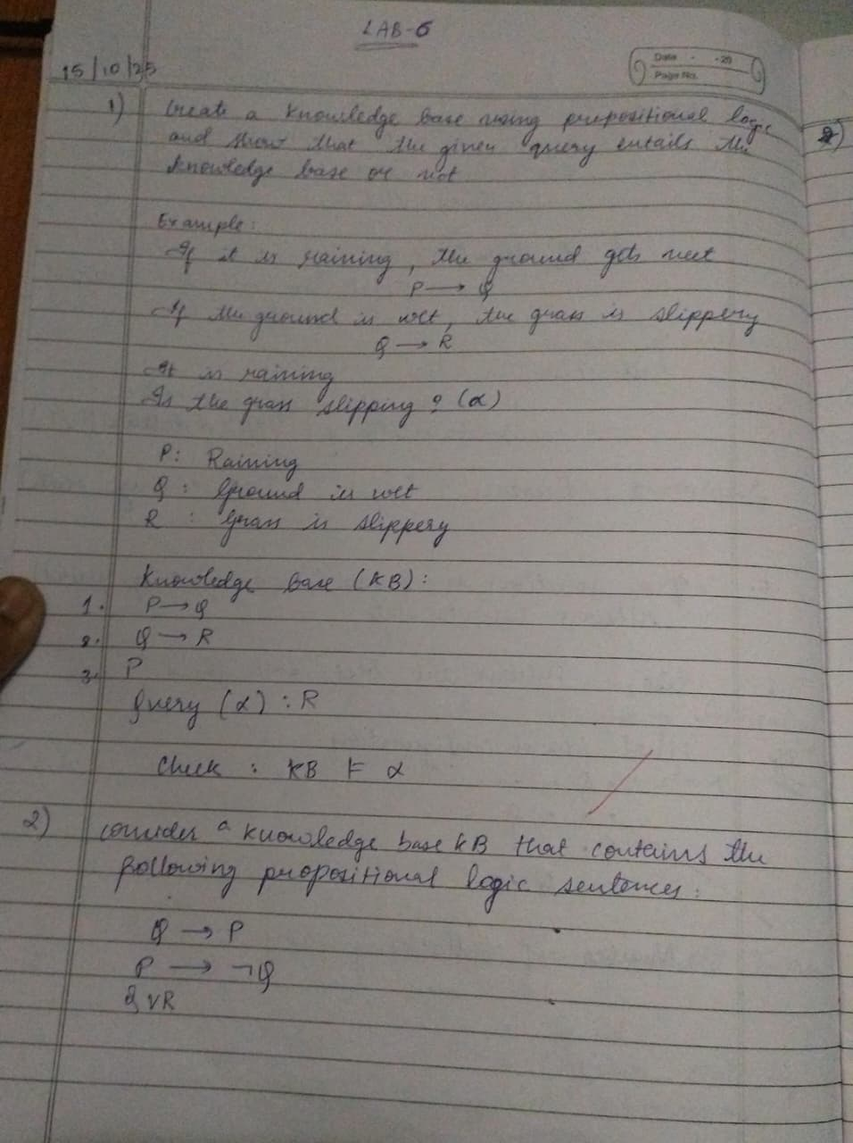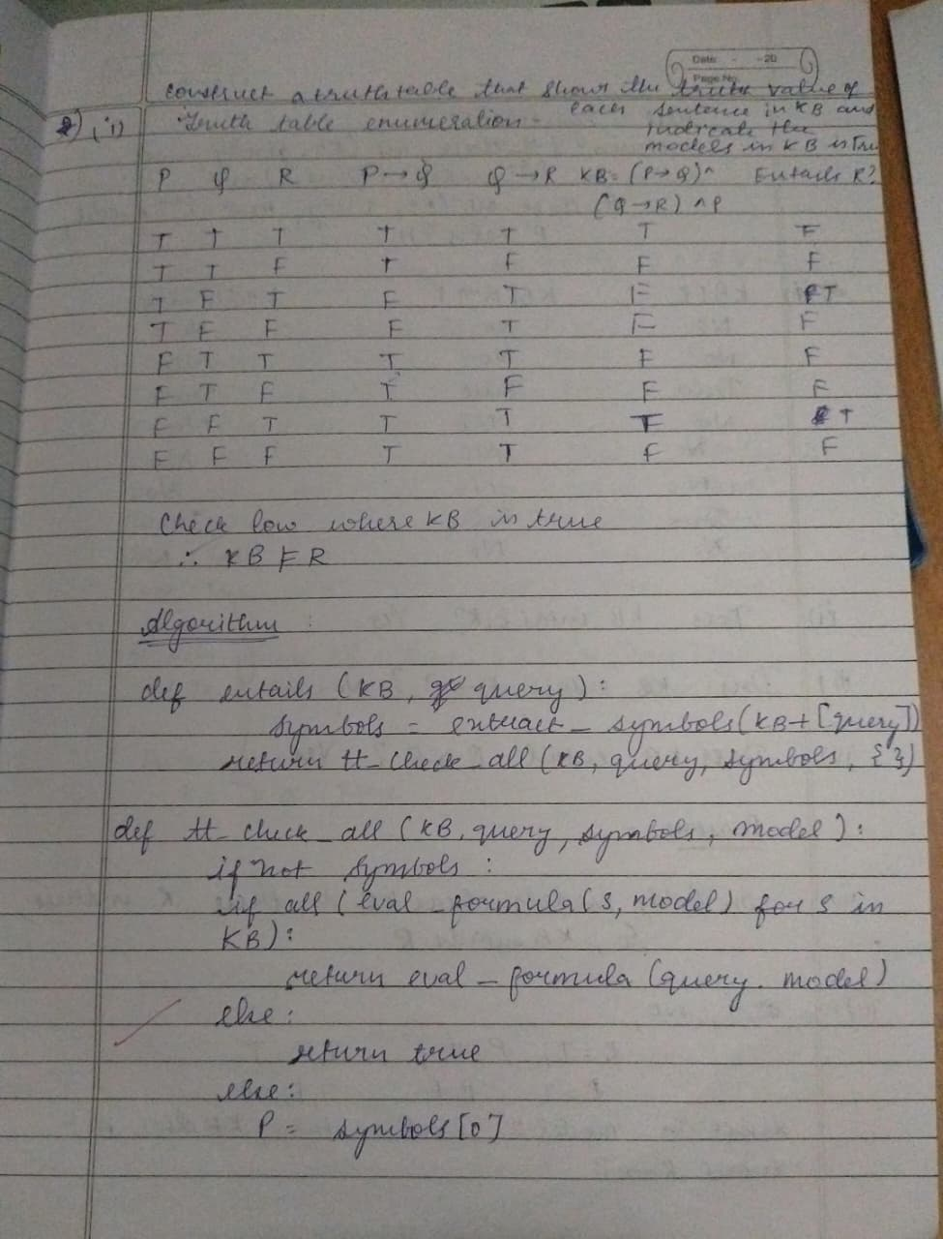

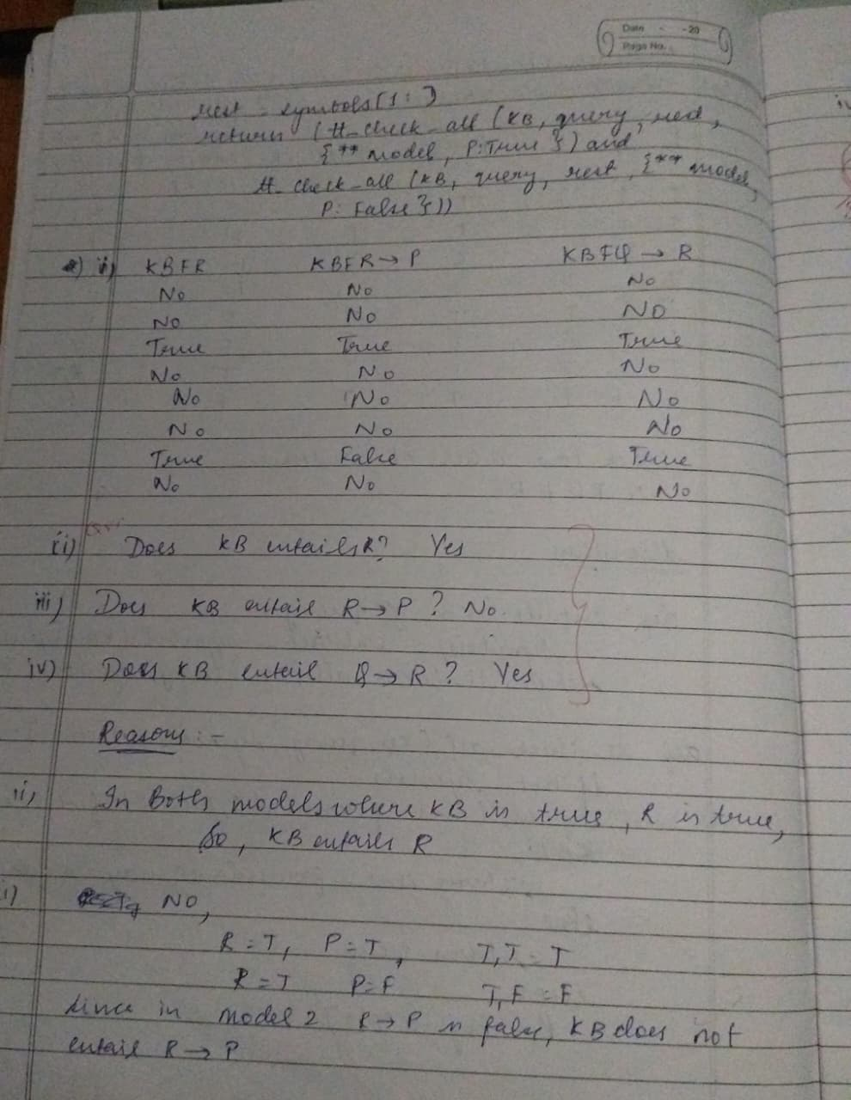
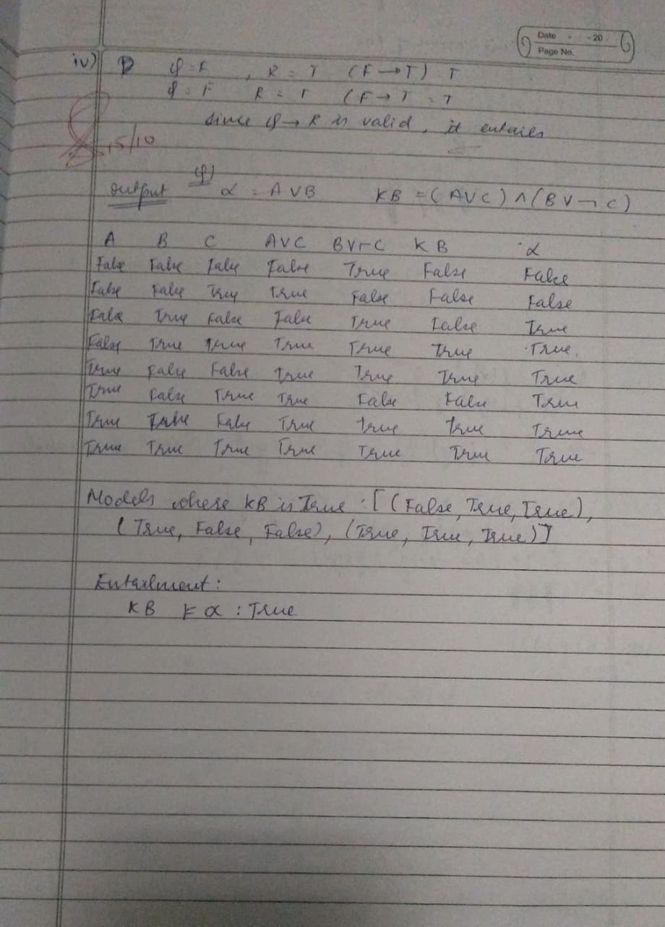

Code:
import itertools

def eval_expr(expr, model):
try:
return eval(expr, {}, model)
except:
return False

def tt_entails(KB, query):
symbols = sorted(set([ch for ch in KB + query if ch.isalpha()]))

print("\nTruth Table:")
print(" | ".join(symbols) + " | KB | Query")
print("-" * (6 * len(symbols) + 20))

entails = True
for values in itertools.product([False, True], repeat=len(symbols)):
model = dict(zip(symbols, values))
kb_val = eval_expr(KB, model)
query_val = eval_expr(query, model)

row = " | ".join(["T" if model[s] else "F" for s in symbols])
print(f"{row} | {kb_val} | {query_val}")

if kb_val and not query_val:
entails = False

return entails

KB = input("Enter Knowledge Base (use &, |, ~ for AND, OR, NOT): ")
query = input("Enter Query: ")

result = tt_entails(KB, query)

print("\nResult:")
if result:
print("KB entails Query (True in all cases).")
else:
print("KB does NOT entail Query.")

Output:
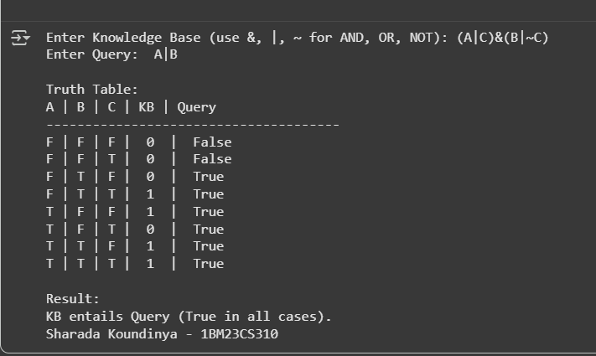

Program 7

Implement unification in first order logic

Algorithm:
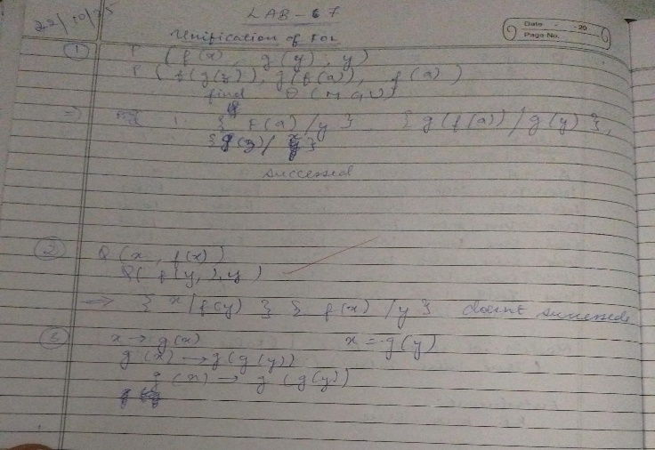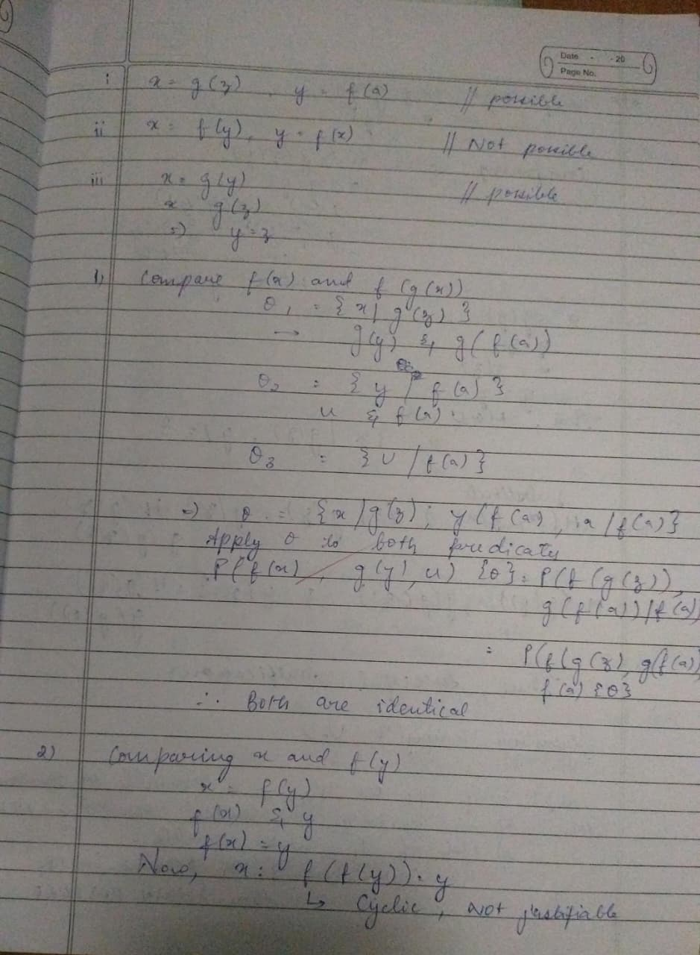

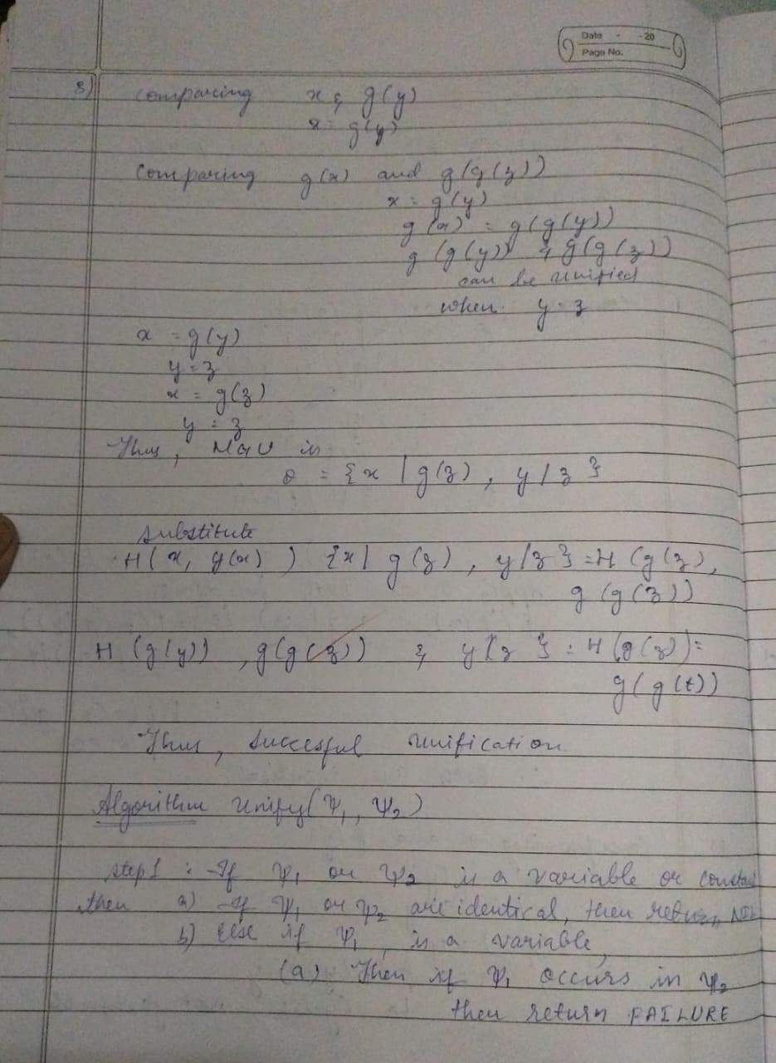
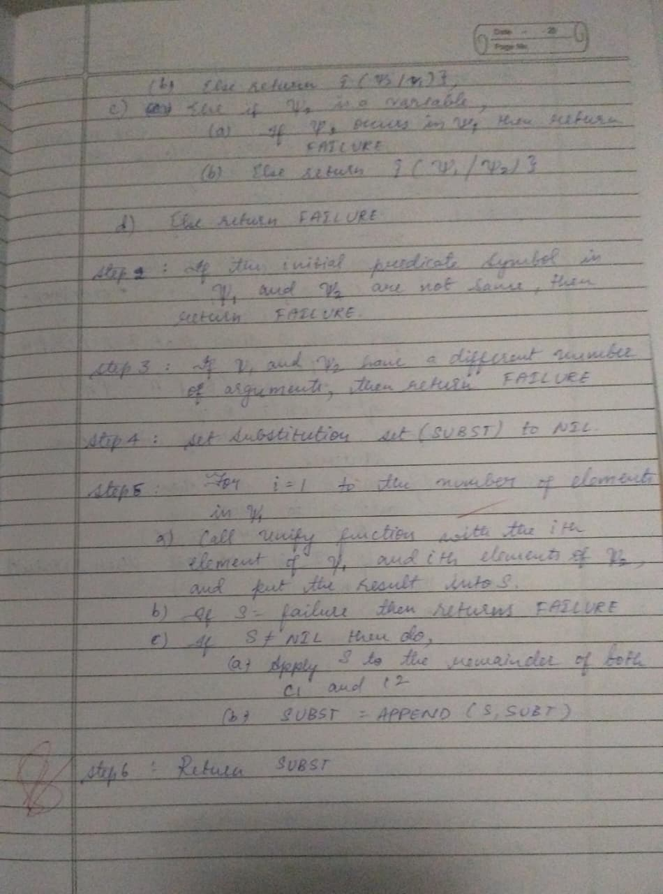

Code:
def occurs_check(var, term, subst):
if var == term:
return True
elif isinstance(term, tuple):
return any(occurs_check(var, t, subst) for t in term)
elif term in subst:
return occurs_check(var, subst[term], subst)
return False

def unify(x, y, subst):
if subst is None:
return None
elif x == y:
return subst
elif isinstance(x, str) and x.isupper():
return unify_var(x, y, subst)
elif isinstance(y, str) and y.isupper():
return unify_var(y, x, subst)
elif isinstance(x, tuple) and isinstance(y, tuple):
if x[0] != y[0] or len(x) != len(y):
return None
for a, b in zip(x[1:], y[1:]):
subst = unify(a, b, subst)
if subst is None:
return None
return subst
else:
return None

def unify_var(var, x, subst):
if var in subst:
return unify(subst[var], x, subst)
elif x in subst:
return unify(var, subst[x], subst)
elif occurs_check(var, x, subst):
return None
else:
subst[var] = x
return subst

def parse_expr(s):
s = s.replace(" ", "")
if '(' not in s:
return s
name_end = s.index('(')
name = s[:name_end]
args = []
depth = 0
current = ""
for c in s[name_end+1:-1]:
if c == ',' and depth == 0:
args.append(parse_expr(current))
current = ""
else:
if c == '(':
depth += 1
elif c == ')':
depth -= 1
current += c
if current:
args.append(parse_expr(current))
return tuple([name] + args)

def expr_to_str(expr):
if isinstance(expr, tuple):
return expr[0] + "(" + ",".join(expr_to_str(e) for e in expr[1:]) + ")"
else:
return expr

expr1_input = input("Enter first expression: ")
expr2_input = input("Enter second expression: ")

expr1 = parse_expr(expr1_input)
expr2 = parse_expr(expr2_input)

subst = unify(expr1, expr2, {})

if subst:
formatted_subst = {var: expr_to_str(val) for var, val in subst.items()}
else:
formatted_subst = None

print("Most General Unifier (MGU):", formatted_subst)

Output:
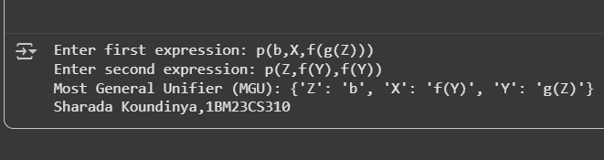

Program 8

Create a knowledge base consisting of first order logic statements and prove the given query using forward reasoning.

Algorithm:
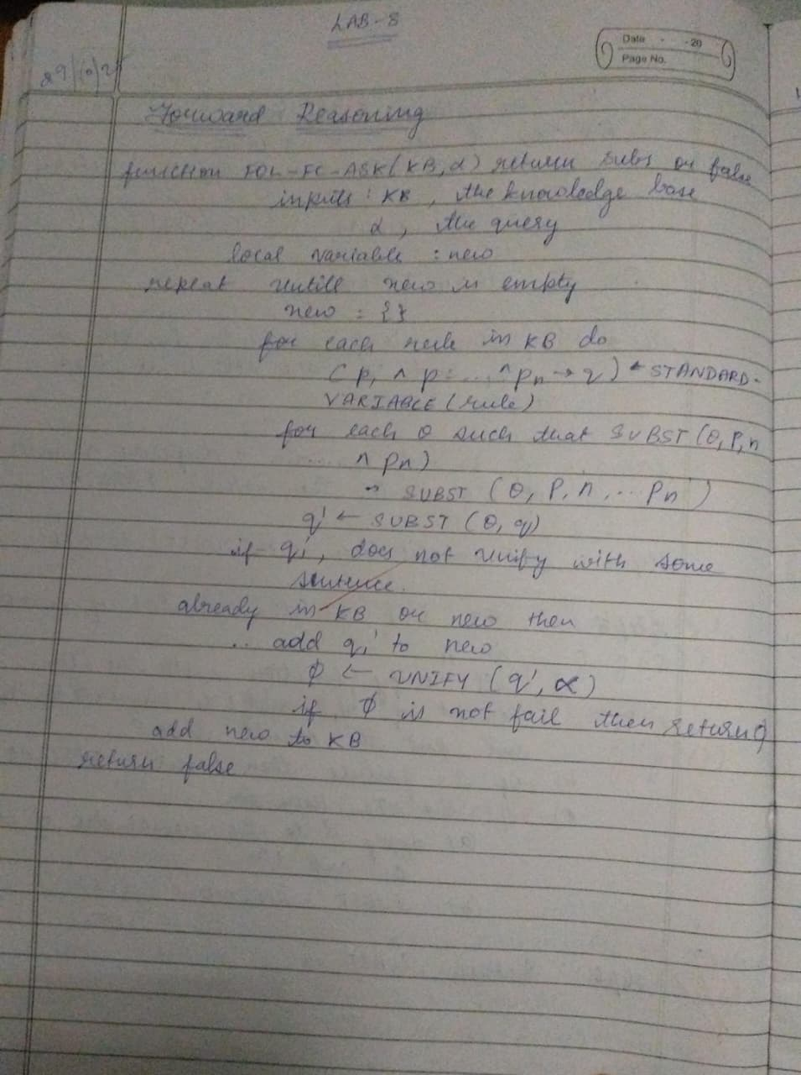

Code:
facts = {
'American(Robert)': True,
'Hostile(A)': True,
'Sells_Weapons(Robert, A)': True
}

If American(X) and Hostile(Y) and Sells_Weapons(X, Y), then Crime(X)
def forward_reasoning(facts):

If American(X) and Hostile(Y) and Sells_Weapons(X, Y), then Crime(X)
if facts.get('American(Robert)', False) and facts.get('Hostile(A)', False) and facts.get('Sells_Weapons(Robert, A)', False):
facts['Crime(Robert)'] = True

forward_reasoning(facts)

if facts.get('Crime(Robert)', False):
print("Robert is a criminal.")
else:
print("Robert is not a criminal.")

Output:
Robert is a criminal.

Program 9
Create a knowledge base consisting of first order logic statements and prove the given query using Resolution

Algorithm:
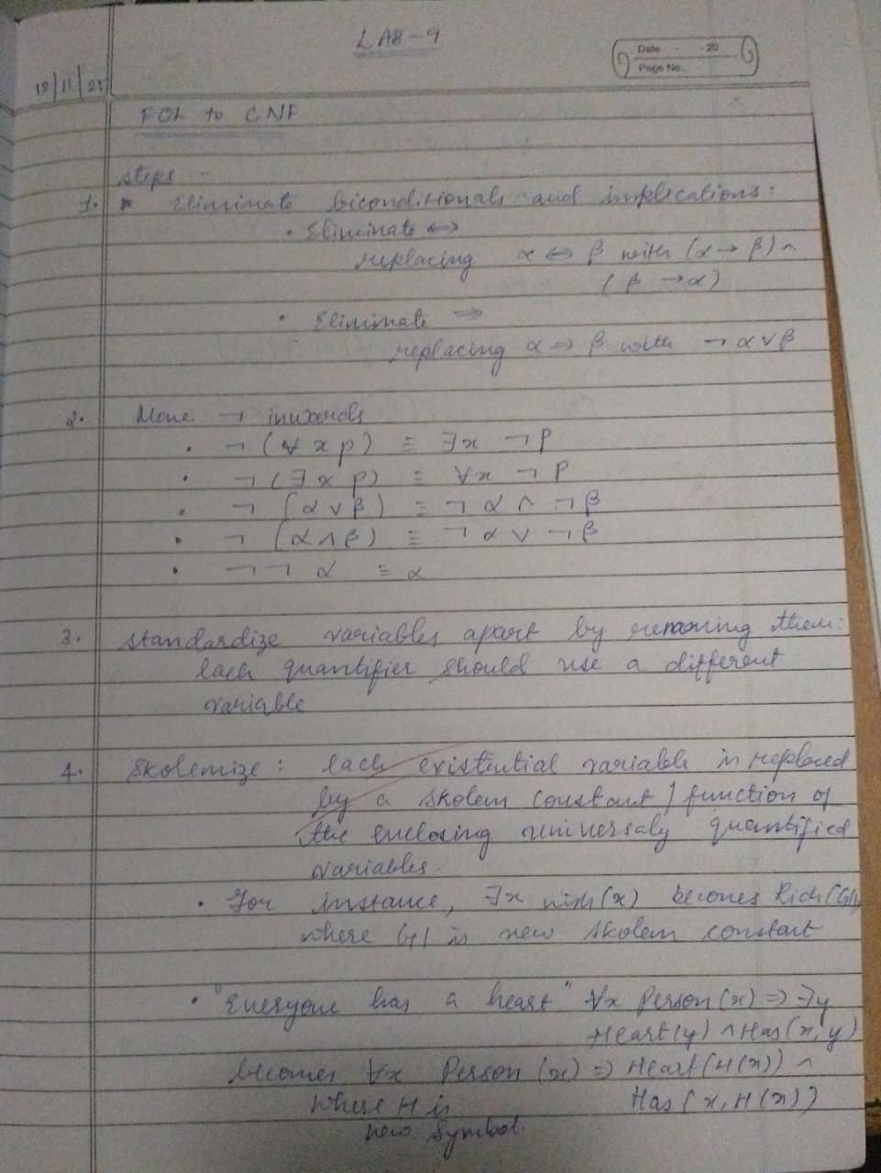
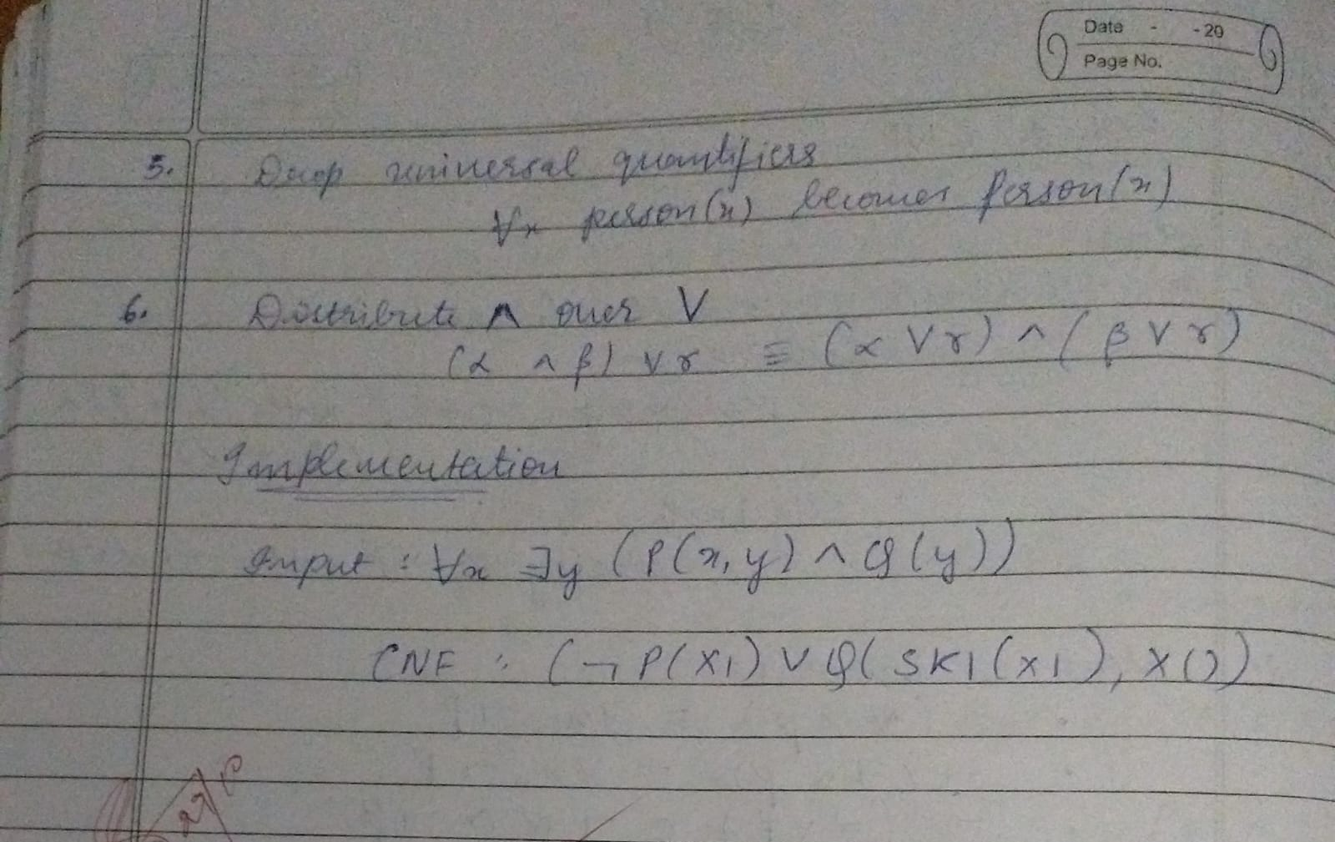
Code:
import copy

def is_variable(term: str) -> bool:
return term[0].islower()

def negate(predicate: str) -> str:
return predicate[1:] if predicate.startswith("~") else "~" + predicate

def parse_predicate(pred):
name = pred[:pred.index("(")]
args = pred[pred.index("(")+1:-1].split(",")
return name, args

def unify(x, y, subst):
if subst is None:
return None
elif x == y:
return subst
elif is_variable(x):
return unify_var(x, y, subst)
elif is_variable(y):
return unify_var(y, x, subst)
else:
return None
def unify_var(var, x, subst):
if var in subst:
return unify(subst[var], x, subst)
elif x in subst:
return unify(var, subst[x], subst)
else:
subst[var] = x
return subst

def unify_predicate(p1, p2):
name1, args1 = parse_predicate(p1)
name2, args2 = parse_predicate(p2)
if name1 != name2 or len(args1) != len(args2):
return None
subst = {}
for a, b in zip(args1, args2):
subst = unify(a, b, subst)
if subst is None:
return None
return subst

def substitute(clause, subst):
new_clause = []
for pred in clause:
name, args = parse_predicate(pred)
new_args = []
for a in args:
new_args.append(subst[a] if a in subst else a)
new_clause.append(name + "(" + ",".join(new_args) + ")")
return new_clause

def resolve(ci, cj):
resolved_clauses = []
for pi in ci:
for pj in cj:
if pi == negate(pj):
subst = unify_predicate(pi.lstrip("~"), pj.lstrip("~"))
if subst is not None:
new_ci = [x for x in ci if x != pi]
new_cj = [x for x in cj if x != pj]
combined = new_ci + new_cj
combined = substitute(combined, subst)
resolved_clauses.append(list(set(combined)))
return resolved_clauses

def resolution(kb, query):
kb = copy.deepcopy(kb)
kb.append([negate(query)])

print("\n--- CNF Clauses ---")
for c in kb:
print(c)

new = set()

while True:
pairs = [(kb[i], kb[j]) for i in range(len(kb)) for j in range(i+1, len(kb))]
for (ci, cj) in pairs:
resolvents = resolve(ci, cj)

for r in resolvents:
if r == []:
print("\nEmpty clause derived → Query PROVED.")
return True
new_clause = tuple(sorted(r))
new.add(new_clause)

new_list = [list(c) for c in new]

if all(clause in kb for clause in new_list):
print("\nNo new clauses → Query CANNOT be proven.")
return False

for clause in new_list:
if clause not in kb:
kb.append(clause)

print("\nEnter number of KB clauses:")
n = int(input())

KB = []
print("Enter clauses in CNF (example: P(x,y) | Q(y)):")

for _ in range(n):
clause = input().replace(" ", "").split("|")
KB.append(clause)

query = input("\nEnter query to prove (e.g., P(a,b)): ")

print("\nRunning Resolution...")
result = resolution(KB, query)

print("\nRESULT:", "TRUE (Proved)" if result else "FALSE (Not provable)")

output:
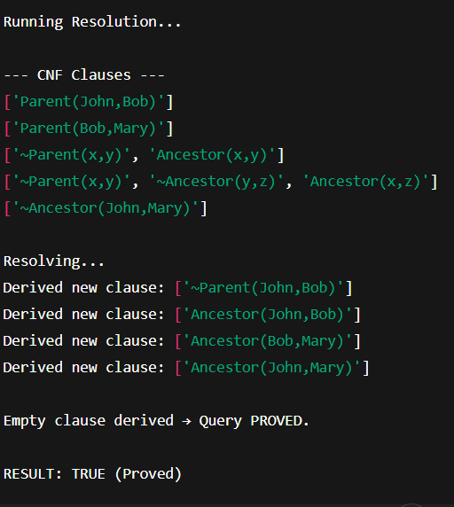

Program 10
Implement Alpha-Beta Pruning.

Algorithm:
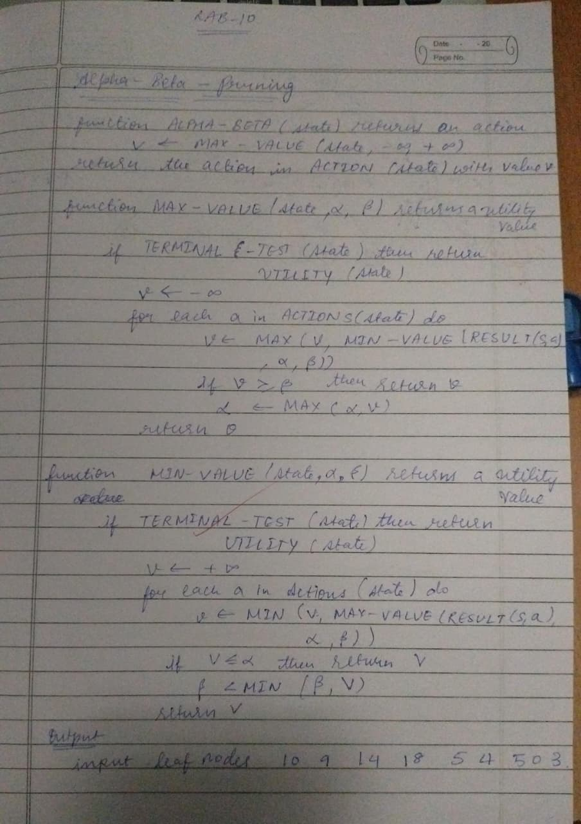

Code:
# Alpha–Beta Pruning Implementation

import math

# minimax with alpha-beta pruning
def alphabeta(depth, node_index, is_max, values, alpha, beta, max_depth):
# If we reach a leaf node -> return its value
if depth == max_depth:
return values[node_index]

if is_max:
best = -math.inf
# Max node → children at next level: node_index*2 and node_index*2+1
for i in range(2):
val = alphabeta(depth + 1, node_index * 2 + i, False,
values, alpha, beta, max_depth)
best = max(best, val)
alpha = max(alpha, best)

# prune
if beta <= alpha:
break
return best

else:
best = math.inf
# Min node
for i in range(2):
val = alphabeta(depth + 1, node_index * 2 + i, True,
values, alpha, beta, max_depth)
best = min(best, val)
beta = min(beta, best)

# prune
if beta <= alpha:
break
return best

# Example leaf node values
values = [10, 9, 14, 18, 5, 4, 50, 3]

# Tree depth = log2(len(values)) = 3
max_depth = 3

print("Leaf nodes:", values)
result = alphabeta(0, 0, True, values, -math.inf, math.inf, max_depth)

print("\nOptimal value obtained using Alpha-Beta Pruning =", result)

output:
